# Creating graphs in Stata

Below we review some diagnostic plots available in Stata, and we demonstrate how to overlay plots. We use auto.dta, which contains pricing and mileage data for 1978 automobiles.

## Plotting predictions

We are interested in modeling the mean of **mpg**, miles per gallon, as a function of **weight**, car weight in pounds. We can use **twoway lfitci** to graph the predicted miles per gallon from a linear regression, as well as the confidence interval:

sysuse auto, clear

twoway lfitci mpg weight

To see how these predictions compare to our data, we can overlay a scatterplot of the actual data

twoway lfitci mpg weight || scatter mpg weight, title(MPG as a function of weight)

which produces the following graph:

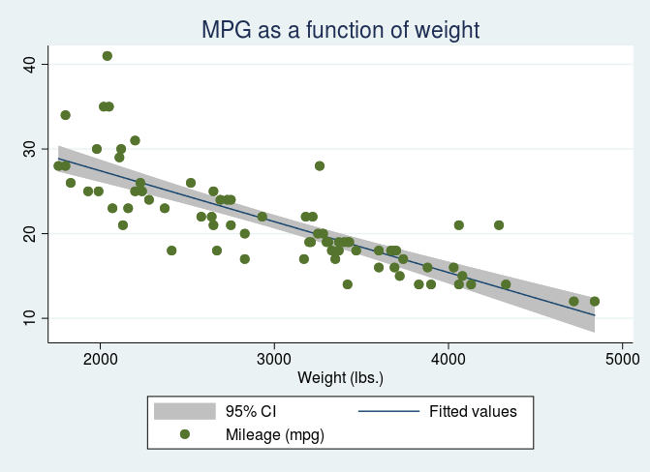

We could have also created separate graphs for domestic and foreign cars with the **by()** option. See [graph twoway lfitci](https://www.stata.com/manuals/g-2graphtwowaylfitci.pdf) in the Stata Graphics Reference Manual for details.

## Diagnostic plot

There are multiple diagnostic plots available for use after **regress**. Here, we use **rvfplot** to graphically check for a relationship between the residuals and fitted values from our model. We regress **mpg** on **weight** and then issue **rvfplot**.

regress mpg weight

rvfplot, yline(0) title(Residuals versus fitted values)

The commands above produce the following graph:

